(Date)

To Whom It May Concern:

Newtown High School Winter Percussion is pleased to announce that they will be making the journey to WGI World Championships in Dayton, Ohio on April 10th, 2019.

All youth have a need to belong, but unlike the vast number of opportunities in sports, there are few extracurricular activities available for those interested in performing arts. Newtown Percussion provides a much needed outlet for those interested in music and dance. The organization provides opportunities for musicians to expand their level of skills while developing into contributing citizens. The mission of the organization is to further the education and growth of young people through participation in performing arts programs of the highest caliber, which promote teamwork and discipline, develop leadership skills, and enhance self-esteem.

The Newtown High School Winter Percussion has been in existence since 2006. It has taken nearly 12 years to prepare this ensemble to compete at the highest level of competitive indoor percussion, WGI World Championships. This ensemble has a tradition of providing a positive learning experience combined with the thrill of competition for young people. The hours of preparation for a common goal provides not only an educational experience, but also lessons in teamwork and group dynamics that benefit members for the rest of their lives. As individuals learn and master their responsibilities, the whole team shares the accomplishment.

Participation in the Percussion Ensemble requires an incredible commitment on behalf of its members. Rehearsals are held from November through the first week of April. In the midst of camp season, members will rehearse for 12 hours a day to prepare for show season that occurs locally during the months of February, March and April. The season will be concluded with a trip to Dayton, Ohio for WGI World Championships.

Between travel, hotels, and other expenses – this season will cost the Percussion program over $30,000. To make this all possible each of the 30 members will be asked to pay a fee of $1,500 for the season. Members ranging from ages 13-18 are willing to do whatever it takes to get to Dayton, Ohio – with your business’s support, you can make their dream a reality. Please consider helping provide this experience to each of the 30 members of the Newtown Community. Your contribution means the world.

Contributor ($200 - $1,000)
Bronze Sponsor ($1,000 - $1,999)
Silver Sponsor ($2,000 - $2,999)
Gold Sponsor ($3,000 - $4,999)
Platinum Sponsor ($5,000 - $9,999)
Nighthawk Medallion ($10,000 +)

Sincerely,

(Name), Newtown High School Winter Percussion Member

(Date)

Thank you for your generous support of my participation in the 2018 Newtown High School Winter Percussion. Your support will make our dream to compete at the 2019 WGI World Championships a reality.

I would also be honored to share pictures, a DVD of our performance, successes, experiences (good and bad), lessons learned, and any other information that might be of interest to you. Please let me know what I can do.

All sponsors will be featured on our 2019 show shirt. This shirt is worn by all 30 members and parents of the Newtown High School Winter Percussion. During the season members are required to wear this before shows, while parents wear them to support their child at a venue. The ensemble will travel to four different states this year, competing in over 15 venues. Please choose below if you would like to be featured or remain anonymous.

As an added, any donation over $5,000 will be printed on banners that will be hung at our home show events held at Newtown High School where hundreds of people from four different states come to attend and enjoy. We would be more than glad to send photos, and follow up any way we can, so please indicate below if you would like to be featured at our events. If you would prefer to remain anonymous that is absolutely fine.

I would like to be featured I would prefer to remain anonymous

Contributor ($200 - $1,000)
Bronze Sponsor ($1,000 - $1,999)
Silver Sponsor ($2,000 - $2,999)
Gold Sponsor ($3,000 - $4,999)
Platinum Sponsor ($5,000 - $9,999)
Nighthawk Medallion ($10,000 +)

Sponsorship Level: ______________________________ Amount: $______________________________________

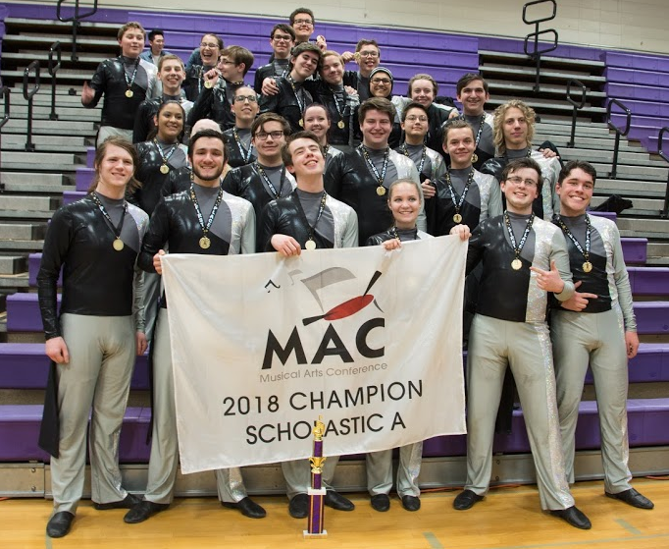
Please make all checks out to: NHSBPC
If you have any questions please email: info@NHSBandGuard.com or call 203-470-7822

Please send all donations to:

C/O NHSWP 2019 Dayton Fundraiser
NHSBPC
Box 3333
Newtown, CT 06470

Thank you again for believing in my team.
Sincerely,

